***DSD LAB SESSION 4***

*Design and simulate 3-way light switch using dataflow modeling in Verilog HDL*

***3-Way Light Switch***

*RTL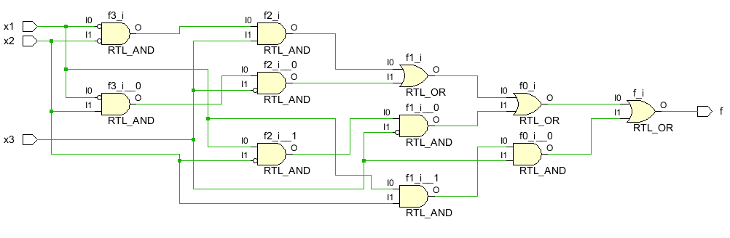SIMULATION*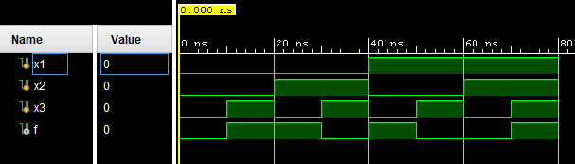

*CONSTRAINT FILE FOR FPGA*

